Question Sheet for learning aim E

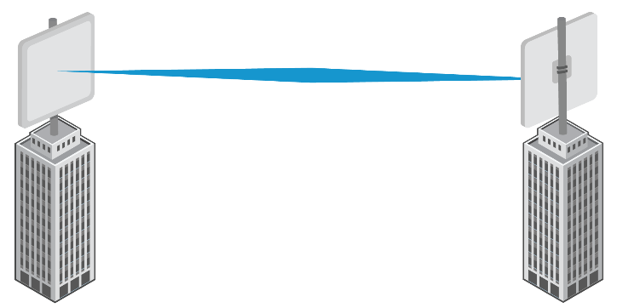Q1: Identify what type of communication channel this is

Duplex

-------------------------

Q2: Describe the differences between lossy and lossless compression

---lossy loses bits and quality whilst lossless doesn’t---

Q3: Explain how to use a Caesar cipher

-----Shift the letter by the value of the key, if the key is “3” A will become D----

Q4: Discuss whether a point to point communication channel or a multi-point communication channel would be better for police services to use to take phone calls reporting crimes

---Multi point would be better as there may be more than one person reporting a crime to the police at once---

Q5: Analyse the 4 types of protocols that two devices use that allow them to communicate

-----TCP, FTP, HTTP, HTTPS------

Q6: Evaluate the needs for error detection and error correction

---Error detection – find errors that stop the program working

Error correction – correct errors to make the program work. ---